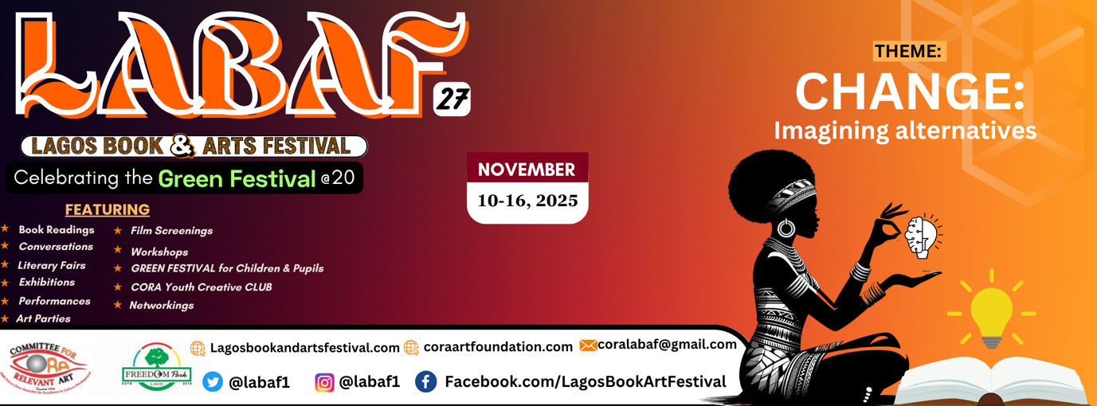

CORA unveils plan for 2025 Lagos Book & Art Festival, LABAF, Nov 10-16
- Affirms the theme 'Change: Imagining Alternatives '

FRONTLINE art and culture advocacy organisation, the Committee for Relevant Art (CORA), has unveiled the plans for the 2025 edition of its flagship project, the Lagos Book & Art Festival (LABAF), which holds November 10- 16 at two venues -- Freedom Park on Hospital Road (by Broad Street|), Lagos Island, and the JRandle Centre for Yoruba Culture and History, at Onikan, Lagos Island.

The theme for the 27th edition of LABAF is: 'Change: Imagining Alternatives', stated the Programme Chair of CORA, Jahman Anikulapo, who is also the festival director.

Festival Highlights
- Main Feature:
- Conversations |Networking | Workshops | Mentorships | Children Festival
- 12 Plenaries on politics, culture and society
- 4 Sessions on Literature in the Digital Age (AI, etc)
- 10 BookTreks (book chats) on fiction, drama, poetry, nonfiction
- 2 days of Green Festival – N: 16 events - Nov 14 & 15
- 2 days of Open Mic
- 2 days of Poetry Competition
- 2 days of CORA Youth Creative Clubs
- 5 visual events/exhibitions
- 4 performances – drama, dance, poetry, etc
- 4 film screenings
- 2 Literary Parties
- And more…

“Our subject, this year, is primarily inspired by the need to encourage new processes to transform our society into a productive, knowledge economy as we progress through the second, quarter century of the world’s fourth largest democracy. The 62-programme of events during the festival hopes to show several points of light in a dark, pessimistic world headlined by Herdsmen killings, Boko Haram sit-ins, and other convulsions in the polity that unsettle us all. Can we all, through books, imagine a world of better possibilities? LABAF 2025 will be spotlighting novels, non-fiction narratives and dramas in which hope, doggedness, the will to win, is a key subject,” said a statement from the LABAF Prog directorate.

The statement continues: that “the focus of the festival remains Literacy Campaign through the instrumentality of the arts in all its dimensions, hence the 62 events that would be held in the course of the one-week duration of the festival will be devoted to using the various disciplines of the arts – literature, visual, performing, media arts, etc – to deepen CORA’s founding objective of educating, enlightening and consequently empowering (3Es) the citizenry to participate in the process of nation building.

“The ultimate aim is to explore the artistic and cultural resources of the nation to help develop its human capital resources for the benefit of the entire society.”

Nature of the festival
“The festival is an open-air, free programme that attracts no gate fees or financial commitment to participants in all the events except to vendors with merchandises,” said the Program Chair, explaining that since its birth in 1999, the festival has been intentional about remaining open-air and free-access because it was “conceived as CORA’s contribution to the spread of literacy towards boosting the capacity of the human resources of the nation, and by extension the African continent, to grow its economic potentialities.”

Character of the festival - Feasting on partnership:
Of the 62 events featuring in the festival, the CORA only conceived and is running only 60 percent, the rest 40 percent are by partner organisations that have remained the pillars of the festival’s sustenance, survival and success in the past 27 years of existence.

The lead partner is Freedom Park, which in the past 15 years has provided its vast lush green ambience as the home of the festival; next is the Children and the Environment, CATE, which for 20 years has consistently staged the Green Festival -- the children-adolescents segment; and there is the Events by Nature, which in past decade, has anchored the CORA Youth Creative Club, CYCC. The two-year old CORA BookTrekkers anchors the youth literary segment.

Other partners include the various associations in the literary and art disciplines, including the Association of Nigerian authors, ANA; Poets Essayists and Novelists, PEN; the National Association of Nigerian Theatre Arts Practitioners, NANTAP, the Society of Nigerian Theatre Artists, SONTA, the Society of Nigerian Artists, SNA, the Pan African Writers Association, PAWA, among others. There are also individual artists who have become part of the DNA of the festival programming content, including the well-travelled performance artist, Jelili Atiku. The 2025 edition enjoys the partnership of the year-old management of the JRandle Centre for Yoruba Culture and History – the fast emerging leader Lagos culture hub located at Onikan, Lagos.

OPERATION
Remarkably, the LABAF operating team is composed mainly of youths in their 20s to the early 30s, who are aggregated under the name CORA Volunteers Corps – these are mostly fresh graduates and undergraduates of tertiary, and allied training institutions in the country. The CVC is supervised by a Board pf Trustees and Governance comprising of eminent art and culture practitioners, including the doyenne of Nigerian stage and screen, Dame Taiwo Ajai-Lycett, the renowned architect, Theo Lawson, the astute art manager, Ms Iyabo Aboaba, the well-garlanded theatre and film producer, Bolanle Austen-Peters, the renowned visual artists, Ndidi Dike, Nkechi Nwosu-Igbo and Olu Amoda, the retired culture bureaucrat, Augustus Babajide Ajibola, former Federal Director of Entertainment and Creative Industries, and other equally renowned artists, lawyers and culture workers. It is chaired by the revered poet, art patron and businessman, Chief Kayode Aderinokun, former chairman of Association of Nigerian Authors, ANA, with the popular soil-scientist, art patron, founder of CORA, Toyin Akinosho as Secretary-General.

RESOURCES
Though a largely contributory festival with programming contents by partner ornisations, the LABAF is supported in terms of resources by a few corporate institutions, and contributions by/and goodwill of some members of its boards. The core segment of the programme content, the CORA BookTreks, is supported by through grants by the Hawthornden Foundation.

ABOUT LABAF: Founded in 1999, LABAF is a 7-day grand literary and cultural “feast of Ideas and Life” with generous book content. The main objective is to deepen the spread of literacy as a vehicle of EDUCATION, ENLIGHTENMENT and EMPOWERMENT. NB: Details at www.lagosbookandartsfestival.comMore at www.lagosbookandartsfestival.com.

ABOUT CORA: The Committee for Relevant Art is a group of artistes, art enthusiasts, art promoters and art writers committed to the development of the Arts of Nigeria and their enabling environment. Its mission is: To Create an Enabling Environment for the Flourishing of the Contemporary Arts of Nigeria and the Continent.
More at: www.coraartfoundation.com

*Issued by LABAF 2025 Media Team.

